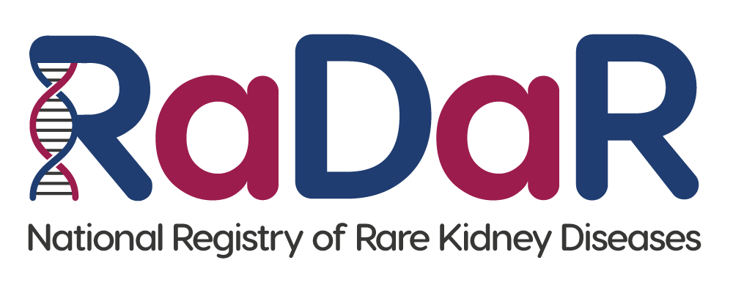

|  |
| --- |
| Patient RaDaR No:  Patient First name, Last name:  Patient Address:  Patient NHS No/CHI No: |

**Adult Consent Form (Age 16+)**

If you agree, please initial box

|  |  |
| --- | --- |
| 1. I confirm that I have read the RaDaR Patient Information Sheet dated........................ (Version........).   I have had the opportunity to consider the information, ask questions and have had these answered satisfactorily. |  |
| 1. I understand that my participation is voluntary and that I am free to withdraw at any time without giving any reason, without my medical care or legal rights being affected. |  |
| 1. I understand that relevant sections of my medical notes and data collected during the study, may be looked at by individuals from RaDaR, from regulatory authorities or from the NHS Trust, where it is relevant to my taking part in this research. I give permission for these individuals to access my records. |  |
| 1. I understand that my past, present and future data will be used for ongoing and future research and may be shared anonymously with other researchers. |  |
| 1. I understand that my data will be linked to other data sources as described in the Patient Information Sheet, and that my personal identifiers (including NHS number and Date of Birth) will be used to search such records. |  |
| 1. I understand that the information held and maintained by RaDaR will be used by the central RaDaR team and Rare Disease Group Lead to contact me. |  |
| 1. I agree to take part in RaDaR. |  |

Name of Participant Date Signature

Participant email address: __________________________________________________

Name of Person Date Signature

receiving consent